Reforms and counter-reforms under Alexander III

Theme | Social Conditions
 | Proletariat (workers) | Peasantry | Economy | Economy | Religion / Russification | Police / Politics
Key person | Bunge  (Minister of Finance 1881-87) | Ignatiev  (Minister for the Interior 1881-87) | Vyshnegradsky  (Minister of Finance 1887-92) | Witte  (Minister of Finance 1892-1903) | Pobedonostsev  (Head of Holy Synod) | (Head of the Okhrana 1884-1994)
 | 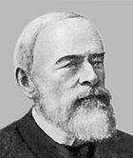 | 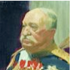 |  | 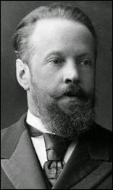 | 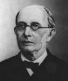 | 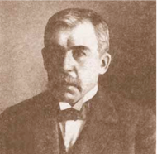
 | REFORMERS: Both believed that the best way to defeat socialism was to improve the condition of the people. |  | ECONOMIC REFORMER  BUT SOCIAL REACTIONARY: | ECONOMIC & SOCIAL REFORMER: | REACTIONARIES: Both believed that the reforms of Alexander II had destabilised the country by encouraging demands for further reform.
POLICIES |  |  | ECONOMIC  SOCIAL |  | RELIGION  RUSSIFICATION

