***In 1348 the Black Death arrived in England from the Continent. It effects were devastating, killing up to 50% of the population and changing the social structure of England forever. This period was documented by the ‘Father of English poetry’...***

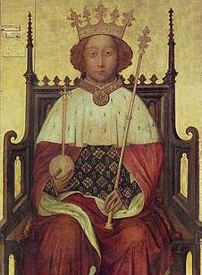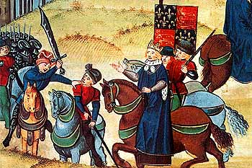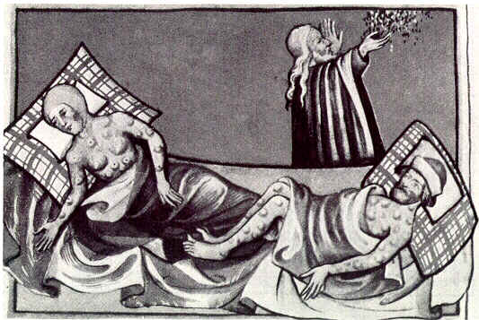

***Richard II’s reign was riddled with crises. He often struggled to get the support of his nobles and was accused of acting as a tyrant, particularly when it came to taxes. The fact that he had powerful cousins like Henry Bolingbroke (the future Henry IV) led to continual...***

***Richard II***

***In 1381 peasants from Kent and Essex, led primarily by Wat Tyler and buoyed by an increase in their personal wealth, demanded of the boy king Richard II, greater civil rights and lower taxes. This was the 13 year old king’s greatest challenge yet, but he put down the revolt and hung its leaders...***

***Peasants’ Revolt***

***The Black Death***

[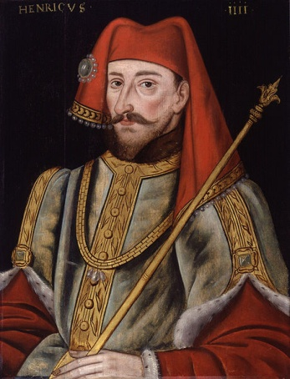](http://upload.wikimedia.org/wikipedia/commons/b/b4/King_Henry_IV_from_NPG_(2).jpg)

***In 1398 this rivalry between the Yorkist (Richard) and Lancastrian (Henry) factions came to a head when Richard exiled Henry for treasonous activities. Henry returned a year later and deposed his cousin of the throne. At this time of internal struggles, an external struggle was continuing to drain England’s resources...***

***Familial rivalries***

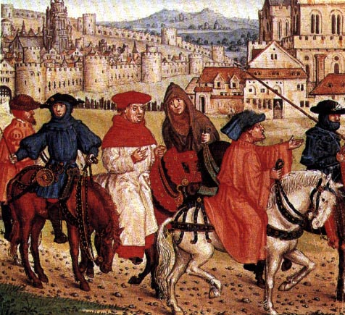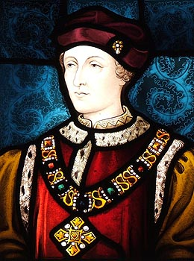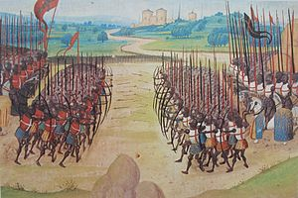[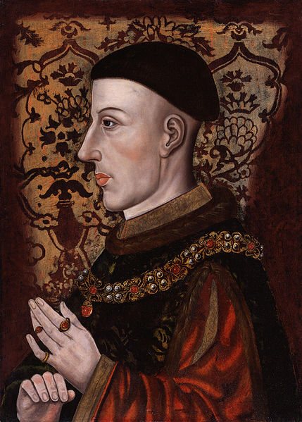](http://upload.wikimedia.org/wikipedia/commons/1/18/King_Henry_V_from_NPG.jpg)

***Chaucer was actually related by marriage to Edward III’s son, John of Gaunt (the founder of the Lancastrian line) but is most famous for his Canterbury Tales, a collection of poems revealing what England was like during the second half of the 14th century. As a result of the Black Death, by 1381 English peasants were experiencing new found prosperity, leading to the...***

***Often regarded as a poor leader, too reliant upon the advice of court nobles and his queen, Margaret of Anjou, Henry VI oversaw the loss of virtually all lands in France. Diagnosed with madness several during his life, he did however found Eton School and Cambridge University. His poor rule led to his deposition by Edward IV, starting the Wars of the Roses.***

***Henry VI***

***Henry V led perhaps the most famous English victory of the Hundred Years War, when he defeated the French army at Agincourt. This is immortalised by Shakespeare’s famous line,* “**Cry **‘God for** Harry, England, and Saint George**!” The Hundred Years War helped form English and French ideas of nationalism (fierce patriotism). The war came to an end in the reign of...**

***More a collection of wars between 1337 to 1453, it had its roots in the claims of the Plantagenet kings of England (e.g. Henry II) on lands in France (they were from Anjou in Western France).The battle of Crecy in 1346 was won by the English due to the superiority of English longbowmen, and large parts of northern France were gained...***

***The Hundred Years War***

***Geoffrey Chaucer***

***Henry V***