[](http://www.google.co.uk/url?sa=i&rct=j&q=&esrc=s&source=images&cd=&cad=rja&uact=8&docid=T3eOwLw6U7wvMM&tbnid=18ZLR2dQCuzwPM:&ved=0CAUQjRw&url=http://windsbird.wordpress.com/2013/07/20/was-there-a-romance-between-richard-iii-and-elizabeth-of-york/&ei=hguwU6zfBu3Z0QW3tIDYDA&bvm=bv.69837884,d.d2k&psig=AFQjCNF0U7Z3ML5scJ4eylmdCws59Antgw&ust=1404132553438806)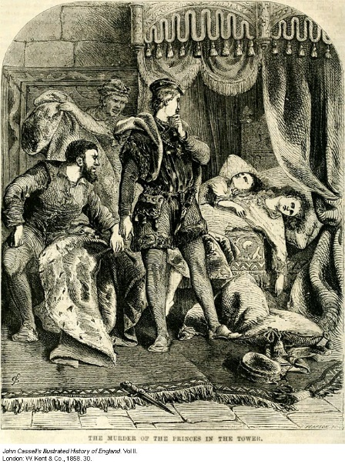[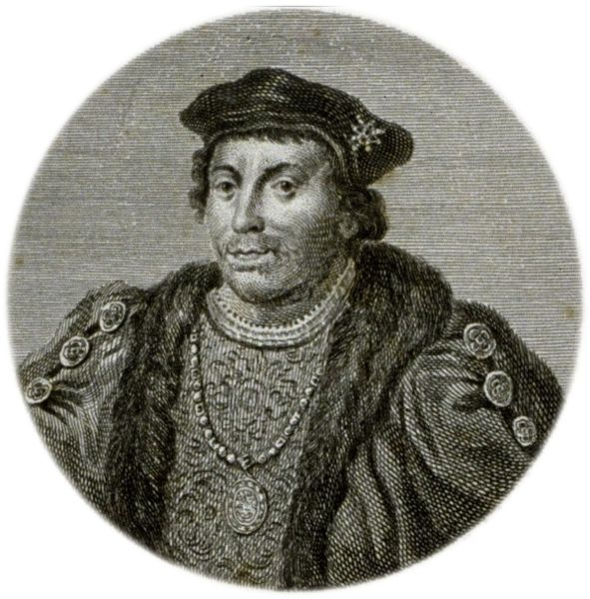](http://www.google.co.uk/url?sa=i&rct=j&q=&esrc=s&source=images&cd=&cad=rja&uact=8&docid=LMmmnEL9pABtqM&tbnid=VhB-7GILjBTH4M:&ved=0CAUQjRw&url=http://www.house-empire.com/personpage.lasso?token.cardid%3D4062&ei=KxewU5_sOszM0AXJvYGoAw&bvm=bv.69837884,d.d2k&psig=AFQjCNE4sDr07P5fKwwkmwszQn7wcAnvLA&ust=1404135531060826)[](http://www.google.co.uk/url?sa=i&rct=j&q=&esrc=s&source=images&cd=&cad=rja&uact=8&docid=7gZkaXZAl0xqYM&tbnid=Yyyhfiua3P00NM:&ved=0CAUQjRw&url=http://www.bbc.co.uk/arts/yourpaintings/paintings/king-henry-vii&ei=IQywU92AGcPO0AXmvIHQAw&bvm=bv.69837884,d.d2k&psig=AFQjCNFNqaI43kJUyDf6C3JQrDikm4UH8Q&ust=1404132741687130)

Richard III

Duke of Buckingham

Sir James Tyrell

Henry VII